LITERARY DEVICES REVIEW:
Cut out the images to use as flashcards. Write the corresponding answer on the back to use for review.
Key:

- Alliteration: Any time there is any repetition of the initial consonant.
- Allusion: Any reference to a famous person or event in life or literature.
- Foreshadowing: It gives you a hint as to what is going to happen next.
- Hyperbole: A figure of speech involving exaggeration.
- Idiom: A style or form of artistic expression where the phrase means something different than what the words seem to mean.
- Metaphor: A comparison where one thing is said to be another.
- Onomatopoeia: The use of words to imitate the sounds they describe.
- Personification: Giving human-like qualities to animals or objects.
- Repetition: The act or an instance of repeating or being repeated.
- Simile: A figure of speech comparing unlike things using “like”, “as”, or “as though”.

1)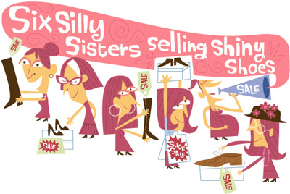 2)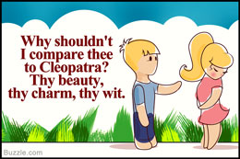

3)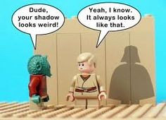 4)

5)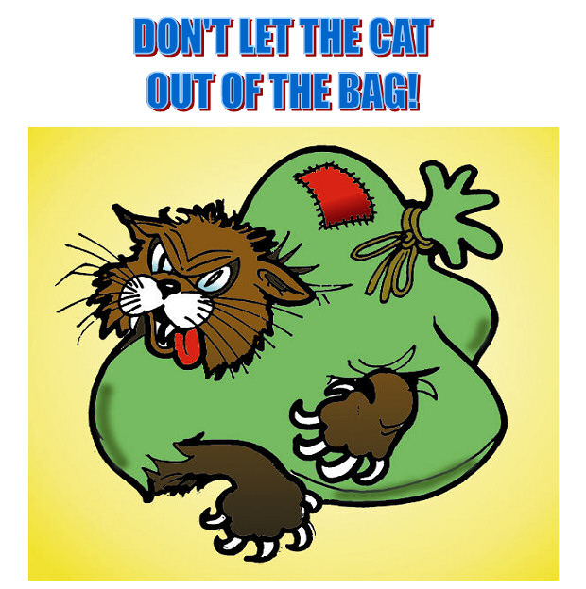 6)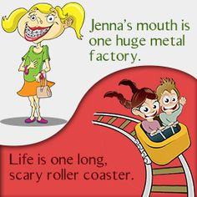
7)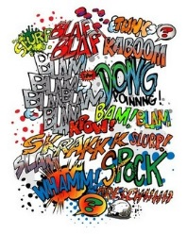 8)

9)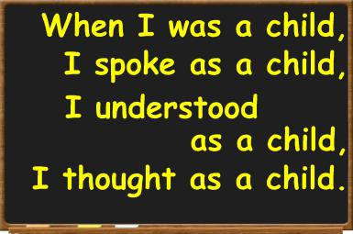 10)

